**UPPER RIO GRANDE WATER OPERATIONS MODEL**

**URGWOM Accounting Concepts and Methods**

**VOLUME 3**

Version 9.3

September 26th, 2024

*Submitted to:*



U.S. Army Corps of Engineers

Albuquerque District

4101 Jefferson Plaza NE

Albuquerque, New Mexico 87109

*Prepared by:*

**

Tetra Tech, Inc.

6121 Indian School Road NE, Suite 205

Albuquerque, New Mexico 87110

**Tetra Tech Inc.: Contract W912PP-19-D-0025, Delivery Order No. W912PP21F0020**

Page intentionally left blank.

Table of Contents

Table of Contents i

List of Tables iii

List of Figures iii

Abbreviations and Acronyms Used iv

1. Introduction 1

2. Accounting Background and Concepts 1

2.1. Water accounting practices prior to URGWOM 3

2.2. Reporting 4

2.3. Basics of accounting model 5

2.4. Model layout 8

2.5. Operational Policy Rules 8

3. Accounting Methods 9

3.1. Reservoir Gain Loss Calculations 9

4. Sedimentation 16

4.1. Sediment Deposition Calculations 17

4.2. Transportation Lags and Losses 21

5. Heron Reservoir 24

5.1. Storage Accounts 24

5.2. Inflow Calculations 26

5.3. Mass Balance Equation 26

5.4. Ratio Inflow Method 27

5.5. Seepage Method 28

5.6. Net End-of-Month Gain Method 28

5.7. Determination of Rio Grande Inflow 30

5.8. Storage and Loss Calculations 33

6. El Vado Reservoir 33

6.1. Storage Accounts 34

6.2. Operation for Rio Grande Water 34

6.3. Restrictions of the Rio Grande Compact 35

6.4. Water Right Constraints on Operation for Rio Grande Water 35

6.5. Multiple Rio Grande Accounts in El Vado 35

6.6. Operation of San Juan-Chama Water 35

6.7. Rio Grande and San Juan-Chama Project Storage Calculations 36

7. Abiquiu Reservoir 36

7.1. Storage Accounts 36

7.2. Operation for Rio Grande Water 37

7.3. Operation for San Juan-Chama Project Water 38

7.4. Rio Grande and San Juan-Chama Storage Calculations 38

8. Cochiti Reservoir 38

8.1. Storage Accounts 38

8.2. Operation for Rio Grande Water 39

8.3. Rio Grande and San Juan-Chama Storage Calculations 39

9. Jemez Reservoir 39

9.1. Storage Accounts 39

10. Nambe Falls Reservoir 40

10.1. Storage Accounts 40

11. Elephant Butte Reservoir 40

11.1. Storage Accounts 40

11.2. Operation for San Juan-Chama Project Water 41

12. Colorado Accounting 41

13. Object Level Accounting Methods 41

14. References 43

15. Appendix A – Object-level Accounting Method Documentation 44

List of Tables

Table 1. Areas used in reservoir loss calculations 13

Table 2. Sediment Data Parameters for USACE Lakes 19

Table 3. San Juan-Chama Loss Factors and Lags 22

Table 4: 2012 San Juan-Chama Loss from Cochiti to Elephant Butte 23

Table 5. Storage Accounts in Heron Reservoir 25

Table 6. San Juan-Chama Project Contractor Allocations 25

Table 7. Effective Precipitation 29

Table 8. Apparent inflow to Heron Reservoir (From 2020 Water Accounting Report, USBR). Column 6, “Tributary Inflow Within Heron Reservoir” Reports calculated net gain on reservoir 31

Table 9. Storage Accounts in El Vado Reservoir 34

Table 10. Storage Accounts in Abiquiu Reservoir 37

Table 11. Storage Accounts in Cochiti Reservoir 39

Table 12. Storage Accounts in Jemez Reservoir 39

Table 13. Storage Accounts in Nambe Falls Reservoir 40

Table 14. Storage Accounts in Elephant Butte Reservoir 41

Table 15. User-developed OLAMs used in URGWOM 42

List of Figures

Figure 1. Upper Rio Grande Basin. 2

Figure 2. Green Book data objects. 4

Figure 3. Reporting data objects. 5

Figure 4. Storage accounts in Elephant Butte Reservoir. 6

Figure 5. SurfaceWaterDiversion Account on the AlbuquerqueWaterUser object allows for water to be diverted to Albuquerque Bernalillo County Water Utility Authority. 7

Figure 6. SantaFeCity and SantaFeCounty diversion account allow diversion of water at the Buckman Diversion. 7

Figure 7. Example of Passthrough accounts on a Reach object below Cochiti Reservoir. 8

Figure 8. Policy rules concerning Rio Grande Compact operations are coded orange and general ownership accounting are coded magenta. 9

Figure 9. Reservoir Gain Loss accounting conditions. 11

Abbreviations and Acronyms Used

ABCWUA Albuquerque Bernalillo County Water Utility Authority

AOP Annual Operating Plan

CADSWES Center for Advanced Decision Support for Water and Environmental Systems

DMI Data Management Interface

EBID Elephant Butte Irrigation District

EDWA Emergency Drought Water Agreement

EPCWID El Paso County Water Improvement District No .1

HDB United States Bureau of Reclamation Hydrologic Database

LRG Lower Rio Grande

MRGCD Middle Rio Grande Conservancy District

OLAM Object Level Account Method

PandP Prior and Paramount

PVID Pojoaque Valley Irrigation District

RGCC Rio Grande Compact Commission

RPL Riverware Policy Language

SJ-C San Juan-Chama

URGWOM Upper Rio Grande Water Operations Model

USBR United States Bureau of Reclamation

# Introduction

URGWOM (Upper Rio Grande Water Operations Model) was developed with the RiverWare software application developed at the Center for Advanced Decision Support for Water and Environmental Systems (CADSWES) at the University of Colorado at Boulder. The model is a daily or monthly timestep model for simulating operations of facilities and diversions along the Rio Grande and major tributaries within Colorado, New Mexico, Texas, and Mexico. For more information on the model the reader is referred to Volume 1 of the URGWOM documentation, which describes the physical model.

This document serves as a reference for users working with the water accounting features in URGWOM. Other URGWOM Documentation volumes cover such topics as Expression Slot Functions, Physical Processes, Policy ruleset, Initialization ruleset, and other features developed to set up and run the model. The URGWOM Documentation volumes are listed below:

**Volume 1: Physical Documentation**

**Volume 2a: Policy Rules Documentation**

**Volume 2b: Initialization Rules Documentation**

**Volume 2c: Expression Slot Functions Documentation**

**Volume 3: Accounting Concepts and Methods**

**Volume 4: Database Documentation**

**Volume 5: DMI and SCT Documentation**

**Volume 6: User's Manual (Script Documentation)**

# Accounting Background and Concepts

The accounting module of URGWOM is used by the Bureau of Reclamation’s (USBR) Albuquerque Area Office for updating the status of accounts for contractors for San Juan-Chama Project water and other water users in the Rio Grande Basin in New Mexico (Figure 1**).** This module also serves to ensure that the storage and movement of San Juan-Chama water is not included in the calculations of downstream delivery obligations prescribed by the Rio Grande Compact.

Figure ‑. Upper Rio Grande Basin.

The accounting module primarily solves for reservoir inflow using observed flows and reservoir stages, and then calculates all additional loss and storage data to report and store in the model and database. This is the same procedure and methodology originally developed by the USBR and approved by the Rio Grande Compact Commission (RGCC). The accounting module in RiverWare, however, improves the accounting process by linking the releases of San Juan-Chama water to the inflows of the next downstream reservoir. In the process, URGWOM creates (positive or negative) local inflows between reservoirs, representing the unaccounted-for differences between what leaves the upstream reservoir and what arrives downstream. The accounting module calculates total water storage, Rio Grande storage, San Juan-Chama Project water storage, and in some reservoirs, sediment deposition and sediment content effects.

## Water accounting practices prior to URGWOM

URGWOM is designed to duplicate the methods and practices of water accounting that were in place before the model was developed. USBR has established procedures that have been approved by the RGCC to account for San Juan-Chama Project water in the Rio Grande basin. The intent of these accounting procedures is to ensure the native Rio Grande (i.e., native) waters are not impacted by San Juan-Chama water storage and movement throughout the system. This water accounting system determines the portions of the reservoir losses that should be charged to the San Juan-Chama and Rio Grande “pools” within a given reservoir and travel losses through the river system. Previously, these procedures were done with computer programs that were coded in FORTRAN for each reservoir and commonly referred to as the “daily programs”. The FORTRAN code was then ported over to C++ to run in RiverWare as Account Loss methods that can be selected when creating reservoir objects. The subsequent discussions and equations describing the San Juan-Chama and Rio Grande accounting procedures are taken from USBR’s water accounting reports and daily programs and RiverWare Account Loss Methods codes.

All deliveries of San Juan-Chama Project water are noted in a handwritten log of operations referred to as the “Green Book”. These notes include details of the volume, magnitude, source and destination for any deliveries or exchanges. URGWOM has incorporated data objects representing Green Books for the three San Juan-Chama reservoirs (Heron, El Vado and Abiquiu) as well as tables of hand entered and predefined data (Figure 2). The USBR has paper copies of the Green Books dating back to the 1990s. Green Books from 2013 and subsequent years are digital.

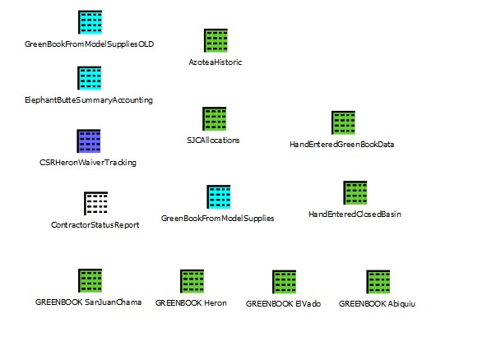

Figure ‑. Green Book data objects.

## Reporting

USBR produces an annual Water Accounting Report for the San Juan-Chama Project. The report details storage and releases from reservoirs, contractor deliveries and relevant losses and depletions through the system. Since approximately 2003, USBR has relied on URGWOM to calculate and track the results that goes into this report. Model results are exported using a Data Management Interface (DMI) (OutputAccoutingtoUCHDB2) into the USBR hydrologic database (HDB) and are pulled from there to generate the report. Data from this report are provided to the RGCC for use in their Compact accounting. URGWOM contains a number of data objects that calculate the reporting results (Figure 3). Additional information on these objects is detailed in Volume 2c: Expression Slot Functions Documentation.

Figure ‑. Reporting data objects.

## Basics of accounting model

The accounting module in URGWOM was built using the fundamental components defined in RiverWare to track ownership and type of water in the simulation. RiverWare documentation developed by CADSWES is available within the software program and should be referenced for a detailed discussion of the structure and use of the various components. The following is a compressed overview of the components relevant to URGWOM based on the CADSWES documentation.

In the URGWOM simulation module, detailed in Volume 1: Physical Documentation, simulated water is referred to as “physical water” and represents the Inflow, Outflow, Storage, etc. between RiverWare objects. As the name implies, physical water represents the actual water that moves through the reservoirs, reaches and aquifers without an association of ownership or designated purpose. The accounting module has “paper water,” which has a specific owner and type that must be tracked. Though physical water is commonly allocated into the accounting network of paper water, physical water and paper water are simulated separately. This leads to the need to reconcile the accounting system with the physical system. Reconciliation occurs through the execution of Object Level Accounting Methods, which are discussed in a subsequent section, or with Operational Policy rules when setting releases for San Juan-Chama contractors and Rio Grande water for predictive models (i.e., Annual Operation Plan (AOP) or Planning applications).

The principal components of the accounting module are “Accounts” and “Supplies”. Accounts are created on simulation objects (reservoir, reach, etc.) and are used to track paper water moving through the system. Accounts identify the owner of the water and the type of water (i.e., San Juan-Chama Project, Rio Grande native). URGWOM utilizes three types of accounts; “Storage”, “Diversion” and “Passthrough” accounts. A storage account represents a legal storage right in a reservoir (Figure 4). In URGWOM, storage accounts have been set on all reservoirs and have an owner of “none”, with the account name indicating the owning entity (i.e., Reclamation, City of Santa Fe, etc.). Storage accounts use type to indicate the source of the water (i.e., San Juan-Chama Project, Rio Grande native).

Figure ‑. Storage accounts in Elephant Butte Reservoir.

Diversion accounts represent a legal right to divert or consume water. Diversion accounts are created on water user or aggregate diversion site objects. In URGWOM, most diversion accounts are associated with Colorado water users. These accounts assign ownership associated with the relevant ditch and have a water right priority date. The priority date is required input for the RiverWare water rights solver which is invoked to allocate and distribute water when routing flows to the Lobatos gage. In New Mexico, diversion accounts are associated with three water users, the surface water diversion of Albuquerque Bernalillo County Water Utility Authority (ABCWUA) on the AlbuquerqueWaterUser object (Figure 5) and the City of Santa Fe and the County of Santa Fe on the BuckmanDirectDiversionObject (Figure 6).

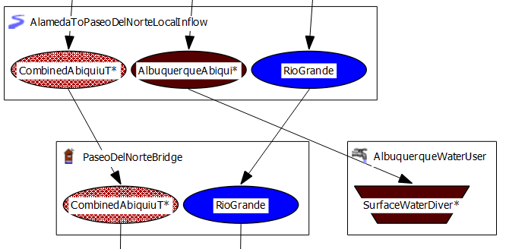Figure ‑. SurfaceWaterDiversion Account on the AlbuquerqueWaterUser object allows for water to be diverted to Albuquerque Bernalillo County Water Utility Authority.

Figure ‑. SantaFeCity and SantaFeCounty diversion account allow diversion of water at the Buckman Diversion.

Passthrough accounts provide a means of transferring paper water between legal accounts (i.e., storage and diversion accounts) but cannot store water. In URGWOM, passthrough accounts are created on reservoirs, reaches, aggregate reaches, confluences and stream gages (Figure 7).

Figure ‑. Example of Passthrough accounts on a Reach object below Cochiti Reservoir.

Supplies are links between two accounts and are used to transfer paper water between accounts. Transfers occur between upstream and downstream accounts, as in the outflow of a reservoir storage account to a downstream passthrough account in a reach, or to a water user at a point of diversion, or a simple transfer between two storage accounts within a reservoir. In URGWOM, supplies are generally used to transfer ownership of San Juan-Chama water between federal and local contractor accounts in the Heron, El Vado and Abiquiu reservoirs, facilitate the movement of San Juan-Chama water to Cochiti and Elephant Butte reservoirs and managing the exchanges of San Juan-Chama and native Rio Grande water between accounts in Elephant Butte reservoirs.

## Model layout

The accounting module is split between Colorado and New Mexico. In New Mexico, accounts and supplies begin at the Azotea Outlet gage and continue through the reaches of the Rio Chama and Rio Grande below the confluence, through Elephant Butte Reservoir and into Caballo Reservoir. At Caballo, individual accounts exist for the Elephant Butte Irrigation District (EBID), El Paso County Water Improvement District No. 1 (EPCWID) and the country of Mexico, however there is no accounting performed in the Lower Rio Grande (LRG) below Caballo. Additionally, supplies and diversions of native Rio Grande water between Lobatos and Embudo are not modeled. URGWOM does track accounting of water in Nambe Falls reservoir, though it is disconnected from the main stem of the Rio Grande. In Colorado, accounting to track priority-based allocations for diversions and delivery of Rio Grande Compact obligations to Lobatos is available, though it has not currently been adopted by the State of Colorado and does not inform the accounting in New Mexico.

## Operational Policy Rules

For predictive type applications (i.e., AOP and Planning), where rules are setting releases for both San Juan-Chama and Rio Grande types of water, URGWOM handles some accounting through the use of Operational Policy Rules. Within the policy ruleset, rules associated with Rio Grande Compact operations are color-coded orange (Figure 8). Among the operations handled by these rules are credit accounting, setting of some supplies and setting storage in Rio Grande accounts. More general accounting operations are included in rules color-coded magenta (Figure 8). These rules handle both Rio Grande and San Juan-Chama water accounts including releases, exchanges and setting of supplies. The reader is referred to “Volume 2a: Policy Rules Documentation” for a complete discussion of these rules.

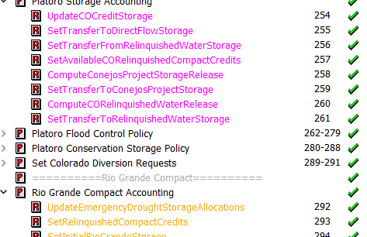

Figure ‑. Policy rules concerning Rio Grande Compact operations are coded orange and general ownership accounting are coded magenta.

# Accounting Methods

URGWOM implements the means of ownership and compact accounting methods that were previously agreed upon by signatories of the Rio Grande Compact and in use before the model was developed. General methods that are not specific to any one reservoir are discussed in the next sections. A discussion of the operations and details of individual reservoirs follows.

## Reservoir Gain Loss Calculations

Over time, physical water stored in reservoirs is subject to uncontrolled losses (evaporation and seepage) and gains (precipitation). (Note: Elephant Butte is the only reservoir for which non-precipitation gains are modeled via the Linked Seepage method, which allows a linked ground water object to contribute flow to Elephant Butte when ground water levels are elevated and the reservoir level is decreasing). Typically, the sum total of these changes amounts to a net loss and these losses must be apportioned to the paper water storage accounts to ensure the accounting module can be reconciled with the physical simulation module. The method detailed below applies to calculating and apportioning these losses is performed at El Vado, Abiquiu, Cochiti, Jemez and Elephant Butte reservoirs, though each reservoir has minor exceptions in the process. Heron and Nambe Falls reservoirs have unique loss calculations that are described separately. Gains and losses in Caballo and Platoro reservoirs are handled by user-defined Object-level Accounting Methods.

For all of the reservoirs in URGWOM, the Account Gain Loss method is selected from a drop-down list of the available Reservoir Account Gain Loss methods in the “Accounting Methods” tab of the Object Viewer:

Figure ‑ Screenshot of the available Reservoir Account Gain Loss methods in URGWOM

In general, losses are calculated for three different conditions: (1) natural losses with no reservoir (pre-reservoir), (2) losses with only Rio Grande water stored (the hypothetical pre-San Juan-Chama Project condition), and (3) losses under actual conditions with both Rio Grande and San Juan-Chama waters in storage (present condition) (Figure 9). A “control area” is defined so that each of the three conditions can be compared with each other. Although the size of the control area is the same from condition to condition, the composition of the control area changes with and without the lake area condition described below. If a reservoir is completely iced over, all losses are set to zero.

Figure ‑. Reservoir Gain Loss accounting conditions.

The control area is an area around and including the lake (Figure 9). The control area is composed of five different areas: barren, irrigated, meadow, river, and lake areas. Losses are computed for each type of area as follows:

|  |  |
| --- | --- |
|  | (eq. ) |
|  | (eq. ) |
|  | (eq. ) |
|  | (eq. ) |
|  | (eq. ) |

where:

= barren-area loss (acre-feet)

$A_{b}$ = barren area (acres)

$P_{eff}$ = effective precipitation (acre-feet)

${AP}_{ows}$ = open water-surface area (percent)

$L_{ia}$ = irrigated-area loss (acre-feet)

$A_{i}$ = irrigates area (acres)

${LR}_{ia}$ = irrigated loss rate (feet)

$L_{ma}$ = meadow-area loss (acre-feet)

$A_{m}$ = meadow area (acres)

${LR}_{ma}$ = meadow-area loss rate (feet)

$L_{ra}$ = river-area loss (acre-feet)

$A_{r}$ = river area (acre-feet)

$E_{l}$ = lake evaporation rate (feet)

$L_{la}$ = lake-area loss (acre-feet)

$A_{l}$ = lake area (acre-feet)

Values for barren, irrigated and meadow areas used for the relevant reservoirs are provided in Table 1. Effective precipitation is discussed Section 5.6.

Reservoir loss computations (evaporation and precipitation) are based on the end-of-day water surface area (elevation). Losses from seepage are only calculated for Heron and Elephant Butte reservoirs. Irrigated-area (${LR}_{ia})$ and meadow-area (${LR}_{ma})$ loss rates are predefined rates for each type and month. Lake evaporation ($E_{l})$ is pan evaporation (when measured) times a pan evaporation coefficient of 0.70 or is average ambient temperature times a monthly K factor when the pan is frozen and not in use. Open water-surface area percentage (${AP}_{ows})$ is the percentage of lake area that is open or not covered by ice.

Table . Areas used in reservoir loss calculations

|  |  |  |  |  |  |
| --- | --- | --- | --- | --- | --- |
| Reservoir | Barren (acres) | Irrigated (acres) | Meadow (Riparian) (acres) | River channel (acres) | Lake (acres) |
| **EL VADO** |  |  |  |  |  |
| Pre-reservoir | 1420 | 300 | 1460 | 200 | N/A |
| Hypothetical | 0 to 3180 | (inundated) | (inundated) | 0 to 200 | 0 to 3380 |
| Present | 0 to 3180 | (inundated) | (inundated) | 0 to 200 | 0 to 3380 |
| **ABIQUIU** |  |  |  |  |  |
| Pre-reservoir | 7189 | N/A | N/A | 288 | N/A |
| Hypothetical | 0 to 7189 | N/A | N/A | 0 to 288 | 0 to 7477 |
| Present | 0 to 7189 | N/A | N/A | 0 to 305 | 0 to 7477 |
| **COCHITI** |  |  |  |  |  |
| Pre-reservoir | 6900 | 40 | N/A | 840 | N/A |
| Hypothetical | 0 to 6900 | (inundated) | N/A | 0 to 840 | 0 to 7780 |
| Present | 0 to 6900 | (inundated) | N/A | 0 to 840 | 0 to 7780 |
| **NAMBE** |  |  |  |  |  |
| Pre-reservoir | 33.9 | N/A | 25.1 | 0 | N/A |
| Hypothetical | N/A | N/A | N/A | N/A | N/A |
| Present | 33.9 | N/A | N/A | 0 | 0 to 59 |
| **JEMEZ CANYON** |  |  |  |  |  |
| Pre-reservoir* | 0 | 0 | 0 | 0 | 0 |
| Hypothetical | N/A | N/A | N/A | 0 | Water-surface area (varies) |
| Present | N/A | N/A | N/A | 0 | Water-surface area (varies) |
| **ELEPHANT BUTTE** |  |  |  |  |  |
| Pre-reservoir | N/A | N/A | N/A | N/A | N/A |
| Hypothetical | N/A | N/A | N/A | N/A | Water-surface area (varies) |
| Present | N/A | N/A | N/A | N/A | Water-surface  area (varies) |

*Between 1980 and 2002, there was storage of San Juan-Chama water. The control and barren areas were 5620 acres, combined.

These areas can be found in the model tableslot <reservoir>.Control and PreRes Areas, e.g. Cochiti.Control and PreRes Areas:

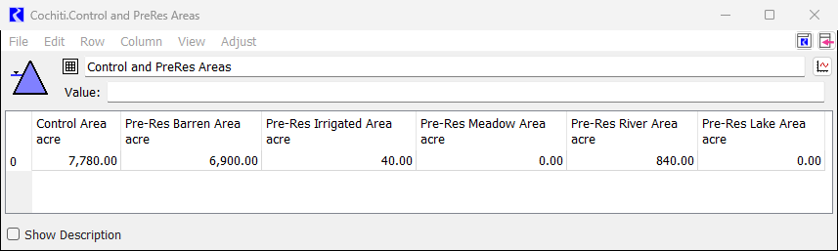

Figure ‑: Example of Reservoir Accounting Gain Loss Areas in URGWOM

### Pre-Reservoir Condition

The pre-reservoir condition approximates natural losses in the control area without the reservoir. The area of each of the four types of areas is fixed (Figure 9). The loss from the pre-reservoir condition is calculated by the equation:

|  |  |
| --- | --- |
|  | (eq. ) |

where:

= pre-reservoir-condition loss (acre-feet)

$L_{{ba}_{pr}}$ = pre-reservoir barren-area loss (acre-feet)

$L_{{ra}_{pr}}$ = pre-reservoir river-area loss (acre-feet)

These pre-reservoir areas and volumes can be found in the model table series slot <reservoir>.PreReservoir Condition, e.g. Cochiti.PreReservoir Condition.

### Hypothetical Condition

The hypothetical condition approximates the losses in the control area without San Juan-Chama Project water. The barren area is the control area minus the lake and river areas (Figure 9). The irrigated and meadow areas are assumed to be inundated by the reservoir. The lake area is computed from the reservoir area-capacity table using the hypothetical lake elevation if only Rio Grande water were stored (filling up from the bottom of the lake). The river area is also based on the “Rio Grande only” lake elevation and the relation of river area to lake elevation. The loss from the hypothetical condition is calculated by the equation:

|  |  |
| --- | --- |
|  | (eq. ) |

where:

= hypothetical-condition loss (acre-feet)

$L_{{ba}_{h}}$ = hypothetical barren-area loss (acre-feet)

$L_{{ra}_{h}}$ = hypothetical river-area loss, based on Rio Grande pool “elevation” (acre-feet)

$L_{{la}_{h}}$ = hypothetical lake-area loss, based on Rio Grande pool “elevation” (acre-feet)

Computation of Rio Grande water content for the hypothetical condition on a given day is not straightforward because the losses are dependent on the content, and the content is dependent on the losses. A reiteration algorithm was developed in the daily programs and utilized in the RiverWare methods code to determine Rio Grande content, water-surface area and losses. The algorithm first estimates Rio Grande content for a given day using the previous day’s Rio Grande content. The Rio Grande losses are computed on the basis of this estimated content. Rio Grande content is then recomputed and compared with the prior value. If they are within 0.5 acre-foot of each other, the most recent Rio Grande content is accepted. If not, an iteration process is initiated using the most recent computed Rio Grande content and re-computing Rio Grande losses until the criterion is met. San Juan-Chama content is computed by subtracting Rio Grande content and, for Corps of Engineers Reservoirs, sediment accumulation from total content.

These hypothetical areas and volumes can be found in the model table series slot <reservoir>.Hypothetical Condition, e.g. Cochiti.Hypothetical Condition.

### Present Condition

The present condition approximates the current losses in the control area under present reservoir conditions (Figure 9).The barren area is the control area minus the lake and river areas. The irrigated and meadow areas are assumed to be inundated by the reservoir. The river area is computed using the observed lake elevation and a table of lake elevation versus river area. The lake area is computed from the reservoir area-capacity table also using today's observed lake elevation. The loss from the present condition is calculated by the equation:

|  |  |
| --- | --- |
|  | (eq. ) |

where:

= present-condition loss, in acre-feet

$L_{{ba}_{p}}$ = barren-area loss, based on observed elevation (acre-feet)

$L_{{ra}_{p}}$ = river-area loss, based on observed elevation (acre-feet)

$L_{{la}_{p}}$ = lake-area loss, based on observed elevation (acre-feet)

If the reservoir is completely iced over, (i.e., open water = 0%), the losses are set to zero.

These areas and volumes can be found in the model table series slot <reservoir>.Present Condition, e.g. Cochiti.Present Condition.

### Net Losses

Net losses, which are applied to the San Juan-Chama and Rio Grande pools, are the losses in excess of natural, pre-reservoir-condition losses. These net losses are computed from the three conditions listed above as follows:

|  |  |
| --- | --- |
|  | (eq. ) |

and

|  |  |
| --- | --- |
|  | (eq. ) |

and

|  |  |
| --- | --- |
|  | (eq. ) |

where:

= net San Juan-Chama loss (acre-feet)

${NL}_{RG}$ = net Rio Grande loss (acre-feet)

Net Rio Grande losses are distributed pro rata between carryover, middle valley conservation and incidental pools based on percentage of storage. The balance of the difference in physical and accounting losses (including sediment) is applied to the incidental pool. Any negative losses (gains) are applied only to the incidental pool.

### Reconciliation of Losses

The difference in accounting losses that are based on water type and ownership will be different from the losses that are based on the total physical water system. The differences should be handled by the equation:

|  |  |
| --- | --- |
|  | (eq. ) |

where:

= daily net loss adjustment (acre-feet)

${NL}_{{phy}_{t}}$ = $E_{t}-P_{t}$ (acre-feet)

$E_{t}$ = total evaporation

$P_{t}$ = total precipitation

These net loss adjustment volumes can be found in the model series slot <reservoir>.Net Loss Adjustment, e.g. Cochiti.Net Loss Adjustment.

# Sedimentation

Sediment accumulation in Abiquiu, Cochiti and Jemez Canyon reservoirs has the practical effect of introducing error in the relationship between water-surface elevation and stored water volume (USBR, 2002). Periodic surveys are designed to update the elevation-volume rating curve and a method was developed for estimating the storage capacity lost to deposition in between surveys based on inflow and reservoir storage. The sediment computation is a multi-step process that results in an estimated volume lost to sediment above and below an operating level at each reservoir. Only sediment deposition below the operation level is accumulated month by month until a new survey is conducted. Sediment inflow into Heron, El Vado, Nambe Falls and Elephant Butte is considered to have a negligible effect on storage calculations.

## Sediment Deposition Calculations

The total daily sediment load for each reservoir is calculated by estimating both suspended-sediment and bed load contributions using exponential equations. Suspended sediment is estimated by an exponential equation of the following form:

|  |  |
| --- | --- |
|  | (eq. ) |

where:

= suspended-sediment load (tons)

$I$ = total inflow (cfs-day)

$a_{i}$ = coefficient based on inflow

$b_{i}$ = exponent based on inflow

Values for $a_{i}$ and $b_{i}$ vary by month and inflow rate for each reservoir and are contained in the model slot <reservoir>.Seasonal Inflow Coeffs, e.g. Cochiti.Seasonal Inflow Coeffs:

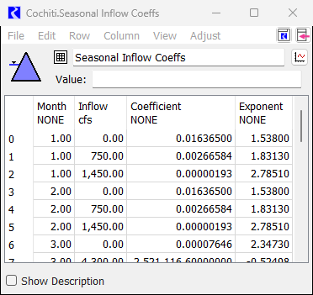

Figure ‑: Screenshot of Seasonal Inflow Coefficients for suspended sediment in Cochiti Lake

Bed load is estimated by an exponential equation of the form:

|  |  |
| --- | --- |
|  | (eq. ) |

where:

= bed load (tons)

$I$ = total inflow (cfs-day)

$c_{i}$ = coefficient based on inflow

$d_{i}$ = intercept based on flow

Values for $c_{i}$ and $d_{i}$ are constant seasonally, but vary by discharge and are contained in the model slot *<reservoir>.Bed Load Coeffs*. Bed load in both Abiquiu and Jemez Canyon is not substantial relative to suspended load, and so both coefficients for these reservoirs are zero. Cochiti reservoir has non-zero coefficients and does compute a meaningful bed load contribution:

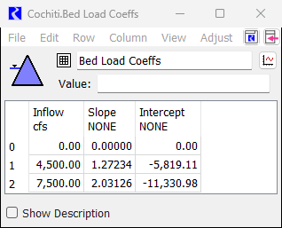

Figure ‑: screenshot of Bed Load Coefficients for sedimentation in Cochiti Lake

Total sediment load is thus the combination of suspended and bed load contributions:

|  |  |
| --- | --- |
|  | (eq. ) |

The sediment deposited above the permanent pool is determined as follows:

|  |  |
| --- | --- |
|  | (eq. ) |

where:

= percentage of sediment above permanent pool

$E_{ws}$ = present water-surface elevation (feet)

$E_{pp}$ = permanent pool elevation (feet)

$E_{z}$ = zero storage elevation (feet)

$a_{ps}$ = percent sediment constant

$b_{ps}$ = percent sediment exponent

Values for $E_{z}$, $a_{ps}$, $b_{ps}$ are constant and are contained in the model slot *<reservoir>.Sed Data* (Table 2**).** The permanent pool elevation ($E_{pp})$ in Abiquiu is constant at 6,220.0 ft. In Cochiti and Jemez Canyon, the permanent pool elevation is recalculated and adjusted on an on-going basis.

Table . Sediment Data Parameters for USACE Lakes

|  |  |  |  |
| --- | --- | --- | --- |
|  | Abiquiu | Cochiti | Jemez |
| Trap Efficiency (TE) | 0.874 | 0.870 | 0.000 (0.965)1 |
| Permanent pool elevation ( $E_{pp})$ (ft) | 6,220.0 ft | varies | varies |
| Zero storage elevation ( $E_{z})$ (ft) | 6,078.26 | 5,255.09 | 5,155.59 |
| Percent sediment constant ( $a_{ps})$ | 0.08934 | 0.08934 | 0.08934 |
| Percent sediment exponent ( $b_{ps})$ | 0.574 | 0.574 | 0.574 |
| Sediment density (${lb}/{{ft}^{3}}$) | 80.81 | 70.76 | 54.60 |

1Prior to the early 2000s, a permanent pool was maintained behind Jemez Canyon Dam. The values in parenthesis reflect the with-permanent-pool condition.

The same sediment unit weight is used for sediment deposited both above and below the sediment deposition elevation ($E_{sd})$. The volume of sediment deposited below $E_{sd}$ is determined by the equation:

|  |  |
| --- | --- |
|  | (eq. ) |

Where:

= sediment deposited below $E_{sd}$ (acre-feet)

${Sed}_{b}$ = total sediment load (tons)

$TE$ = trap efficiency

${Per}_{pp}$ = percentage of sediment above permanent pool

$D_{pp}$ = sediment density in permanent (conservation) pool (lb/ft3)

The Permanent Pool Elevation (Epp), Bed Load (Sedb), Total Sediment Load (SedT), Percentage of Sediment Above Permanent Pool (Perpp), Sediment deposited below Esd (Sedvpp), and accumulated sediment deposited below Esd are all found in the model slot <reservoir>. Est Sed Deposition, e.g., Cochiti.Est Sed Deposition:

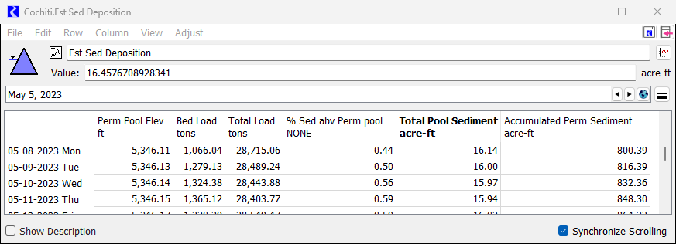

Figure ‑: Screenshot of Cochiti.Est Sed Deposition slot in URGWOM

### Sediment Accumulation Effects

Once the sediment has been quantified for the pool below the permanent pool elevation ($E_{pp})$, the accumulated sediment, ${Sed}_{acc}$, is applied toward the current Rio Grande content. Under normal conditions when there is no middle valley conservation or carryover pools in storage, all of deposited sediment is applied to the incidental storage. The San Juan-Chama content and Rio Grande content are calculated based on the following equations:

|  |  |
| --- | --- |
|  | (eq. ) |
|  | (eq. ) |

where:

|  |  |
| --- | --- |
| = | (eq. ) |

= accumulated permanent sediment (acre-feet)

$S_{SJC}$ = San Juan-Chama content (acre-feet)

$I_{SJC}$ = San Juan-Chama pool inflow (acre-feet)

$O_{SJC}$ = San Juan-Chama pool outflow (acre-feet)

${NL}_{SJC}$ = net San Juan-Chama loss (acre-feet)

$S_{RG}$ = Rio Grande content, which includes carryover pool, middle valley conservation pool and incidental pool storages (acre-feet)

$S_{T}$ = Total content of all pools (acre-feet)

The accumulated permanent sediment is found in the model slot <reservoir>. Est Sed Deposition, and also in the model slot <reservoir>.Accumulated Permanent Sediment. Sediment displaces some of the total capacity of Abiquiu, Cochiti and Jemez reservoirs. For accounting purposes, it is important to calculate accurate capacities of the San Juan-Chama contractor pools without sediment estimates during the year but with one sediment adjustment at the end of the year. The sediment calculated is only an estimate until the reservoir sediment is officially surveyed, and the current reservoir capacity is accurately known.

Total sediment accumulation for the calendar year, estimated by the sediment computation process, that is accounted for in the Rio Grande content is adjusted at the end of each year at each reservoir; the San Juan-Chama Project contractor pools are not affected and remain intact. The City of Albuquerque has the largest allocation in the conservation pool of Abiquiu. Reductions in San Juan-Chama contractor storage space are applied to other contractors first. Once sediment has replaced these other pools, sediment will begin reducing the City of Albuquerque pool. This arrangement is based on contractor agreements with the City of Albuquerque.

The sediment estimate is also used as a daily tool for water managers in determining any Rio Grande incidental water that is in the reservoir. Under normal circumstances, the permanent pool sediment estimate and San Juan-Chama storage together form the “hold pool”, except under special circumstances where Rio Grande water is held as carryover or middle valley conservation pool. A “hold pool” is calculated daily as follows:

|  |  |
| --- | --- |
|  | (eq. ) |

where:

= hold pool content (acre-feet)

$S_{RG}$ = Rio Grande content, which includes carryover pool, middle valley conservation pool and incidental pool storages (acre-feet)

The hold pool content is found in the model slot <reservoir>.Hold Pool, e.g. Cochiti.Hold Pool.

Storage in the amount greater than or less than the hold pool is the incidental storage. This hold pool calculation is the authorized storage in reservoirs used to determine the amount of incidental Rio Grande in storage.

## Transportation Lags and Losses

Transportation losses and lags for San Juan-Chama water released from Heron to downstream locations (except between Cochiti and Elephant Butte) are calculated explicitly based on RGCC accepted values (Table 3). Rio Grande water transportation losses are not directly computed or reported. Instead, they result from comparing the known outflow from one reservoir to the computed inflow to the next reservoir downstream. Differences between these values, incorporating tributary, wastewater and other return flows are then assigned as total losses or gains to the Rio Grande water account. Because URGWOM models all of the reservoirs and reaches together, it represents an improvement in computing Rio Grande water losses over the original daily programs.

Table . San Juan-Chama Loss Factors and Lags

|  |  |  |  |  |  |
| --- | --- | --- | --- | --- | --- |
| From | To | | | | |
|  | El Vado | Abiquiu | Otowi | Cochiti | San Felipe |
| Heron | 1.0000  no lag | 0.9890  1 day | 0.9800  2 day | 0.9767  2 day | Varies1  3 day |
| El Vado | -- | 0.9890  1 day | 0.9800  2 day | 0.9767  2 day | Varies1  3 day |
| Abiquiu | -- | -- | 0.9910  1 day | 0.9877  1 day | Varies1  2 day |
| Otowi | -- | -- | -- | 0.9967  no lag | Varies1  1 day |
| Cochiti | -- | -- | -- | -- | Varies1  1 day |

1 Any ABCWUA water passing from Cochiti to San Felipe is subject to a 1-day lag, and a loss factor ranging from 0.69% to 5.81%, depending on the time of year:

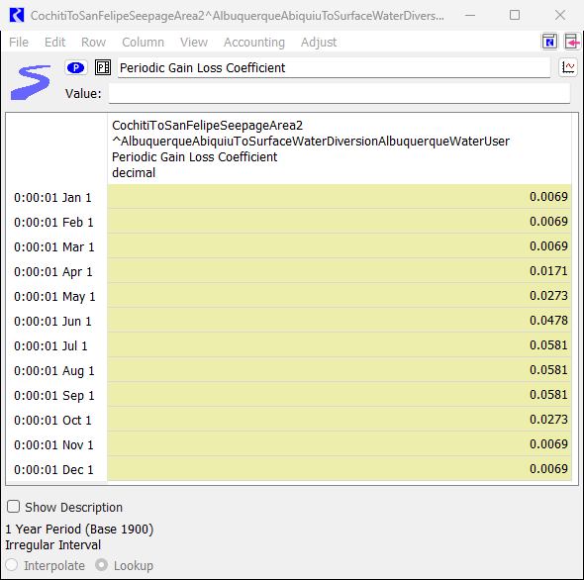

Figure ‑: Screenshot of the CochitiToSanFelipeSeepageArea2^ AlbuquerqueAbiquiuToSurfaceWaterDiversionAlbuquerqueWaterUserPeriodic Gain Loss Coefficient

The El Vado to Abiquiu lag is found in the BlwElVadoToAbvAbiquiu.Variable LagTime Table in the model, and the 0.9890 San Juan Chama loss factor (modeled as a 0.11 loss) is found in each of the BlwElVadoToAbvAbiquiu^<SanJuanChamaAccount>.Gain Loss Coefficient scalar slots:

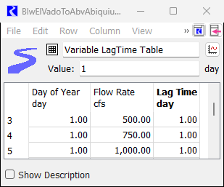

Figure ‑: Screenshot of BlwElVadoToAbvAbiquiu.Variable LagTime Table in model

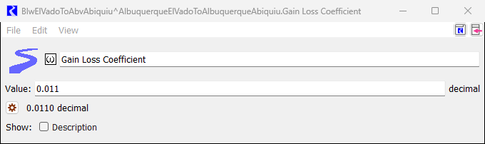

Figure ‑: Screenshot of BlwElVadoToAbvAbiquiu^AlbuquerqueElVadoToAlbuquerqueAbiquiu. Gain Loss Coefficient

The Abiquiu to Otowi lag is found in the BlwAbiquiuToChamita.Variable LagTime Table in the model, and the 0.9910 San Juan Chama loss factor (modeled as a 0.09 loss) is found in each of the BlwAbiquiuToChamita^<SanJuanChamaAccount>.Gain Loss Coefficient scalar slots.

The Otowi to Cochiti 0.9967 loss factor (modeled as a 0.0033 loss) is found in each of the OtowiToCochiti^<SanJuanChamaAccount>.Gain Loss Coefficient scalar slots.

San Juan-Chama water being delivered to Elephant Butte is subject to loss in the Middle Valley. These loss factors were developed in 2012 (USBR, 2012), and are shown in Table 4. The losses range from 6% to 75% (see bolded values below). This loss is applied using the Accounting Method “CochitiToElephantButteSJCLoss” to the SanFelipeToCentralSeepageArea2^CombinedAbiquiuToCombinedElephantButte.Gain Loss slot. Table 4 is found in the “SanJuanChamaRules” object in the model.

Table : 2012 San Juan-Chama Loss from Cochiti to Elephant Butte

|  |  |  |  |  |  |  |  |  |  |  |  |  |  |
| --- | --- | --- | --- | --- | --- | --- | --- | --- | --- | --- | --- | --- | --- |
| **Month** |  | **San Juan-Chama Loss Factor** | | | | | | | | | | | |
| *SJC Release Length (days)* | 5 | 10 | 15 | 20 | 5 | 10 | 15 | 20 | 5 | 10 | 15 | 20 |
| SJ-C Release (cfs) | Native Flow at Cochiti 500-1200 cfs | | | | Native Flow at Cochiti 1200-2000 cfs | | | | Native Flow at Cochiti >2000 cfs | | | |
| January | 0-300 | 0.87 | 0.88 | 0.88 | 0.89 | -- | -- | -- | -- | -- | -- | -- | -- |
| 300-600 | 0.88 | 0.88 | 0.89 | 0.90 | -- | -- | -- | -- | -- | -- | -- | -- |
| 600-900 | 0.88 | 0.89 | 0.90 | 0.90 | -- | -- | -- | -- | -- | -- | -- | -- |
| 900-1500 | 0.89 | 0.90 | 0.90 | 0.91 | -- | -- | -- | -- | -- | -- | -- | -- |
| February | 0-300 | 0.87 | 0.88 | 0.88 | 0.89 | -- | -- | -- | -- | -- | -- | -- | -- |
| 300-600 | 0.88 | 0.88 | 0.89 | 0.90 | -- | -- | -- | -- | -- | -- | -- | -- |
| 600-900 | 0.88 | 0.89 | 0.89 | 0.90 | -- | -- | -- | -- | -- | -- | -- | -- |
| 900-1500 | 0.89 | 0.89 | 0.90 | 0.91 | -- | -- | -- | -- | -- | -- | -- | -- |
| March | 0-300 | 0.85 | 0.86 | 0.87 | 0.87 | 0.87 | 0.88 | 0.88 | 0.89 | -- | -- | -- | -- |
| 300-600 | 0.86 | 0.87 | 0.88 | 0.88 | 0.88 | 0.88 | 0.89 | 0.89 | -- | -- | -- | -- |
| 600-900 | 0.87 | 0.87 | 0.88 | 0.89 | 0.88 | 0.89 | 0.89 | 0.89 | -- | -- | -- | -- |
| 900-1500 | 0.87 | 0.88 | 0.89 | 0.90 | 0.89 | 0.89 | 0.90 | 0.90 | -- | -- | -- | -- |
| April | 0-300 | 0.77 | 0.78 | 0.78 | 0.77 | 0.86 | 0.86 | 0.85 | 0.86 | 0.91 | 0.92 | 0.92 | 0.92 |
| 300-600 | 0.80 | 0.80 | 0.81 | 0.80 | 0.87 | 0.86 | 0.86 | 0.86 | 0.91 | 0.92 | 0.92 | 0.92 |
| 600-900 | 0.81 | 0.82 | 0.83 | 0.82 | 0.87 | 0.87 | 0.87 | 0.87 | 0.91 | 0.92 | 0.92 | 0.92 |
| 900-1500 | 0.83 | 0.83 | 0.84 | 0.84 | 0.88 | 0.88 | 0.87 | 0.88 | 0.92 | 0.92 | 0.92 | 0.92 |
| May | 0-300 | 0.47 | 0.46 | 0.49 | 0.51 | 0.71 | 0.63 | 0.55 | 0.79 | 0.91 | 0.92 | 0.92 | 0.92 |
| 300-600 | 0.55 | 0.56 | 0.58 | 0.60 | 0.73 | 0.68 | 0.61 | 0.81 | 0.91 | 0.92 | 0.92 | 0.92 |
| 600-900 | 0.62 | 0.63 | 0.65 | 0.67 | 0.76 | 0.72 | 0.66 | 0.82 | 0.91 | 0.92 | 0.92 | 0.92 |
| 900-1500 | 0.68 | 0.70 | 0.71 | 0.73 | 0.78 | 0.76 | 0.72 | 0.84 | 0.92 | 0.93 | 0.92 | 0.92 |
| June | 0-300 | **0.25** | 0.30 | 0.31 | 0.36 | 0.58 | 0.59 | 0.58 | 0.66 | 0.90 | 0.90 | 0.92 | 0.93 |
| 300-600 | 0.43 | 0.48 | 0.48 | 0.51 | 0.66 | 0.68 | 0.68 | 0.75 | 0.91 | 0.91 | 0.93 | 0.93 |
| 600-900 | 0.52 | 0.56 | 0.57 | 0.59 | 0.70 | 0.72 | 0.72 | 0.78 | 0.91 | 0.91 | 0.93 | 0.93 |
| 900-1500 | 0.60 | 0.64 | 0.65 | 0.67 | 0.74 | 0.76 | 0.76 | 0.81 | 0.92 | 0.91 | 0.93 | **0.94** |
| July | 0-300 | 0.32 | 0.30 | 0.33 | 0.35 | 0.69 | 0.69 | 0.68 | 0.67 | -- | -- | -- | -- |
| 300-600 | 0.41 | 0.42 | 0.45 | 0.48 | 0.74 | 0.75 | 0.75 | 0.75 | -- | -- | -- | -- |
| 600-900 | 0.51 | 0.53 | 0.56 | 0.59 | 0.77 | 0.77 | 0.79 | 0.79 | -- | -- | -- | -- |
| 900-1500 | 0.60 | 0.62 | 0.65 | 0.68 | 0.79 | 0.80 | 0.81 | 0.82 | -- | -- | -- | -- |
| August | 0-300 | 0.44 | 0.42 | 0.43 | 0.46 | 0.79 | 0.81 | 0.80 | 0.80 | -- | -- | -- | -- |
| 300-600 | 0.55 | 0.55 | 0.57 | 0.59 | 0.81 | 0.83 | 0.82 | 0.82 | -- | -- | -- | -- |
| 600-900 | 0.62 | 0.63 | 0.65 | 0.67 | 0.82 | 0.84 | 0.83 | 0.84 | -- | -- | -- | -- |
| 900-1500 | 0.69 | 0.70 | 0.71 | 0.73 | 0.83 | 0.85 | 0.85 | 0.85 | -- | -- | -- | -- |
| September | 0-300 | 0.67 | 0.68 | 0.69 | 0.70 | 0.83 | 0.85 | 0.85 | 0.84 | -- | -- | -- | -- |
| 300-600 | 0.71 | 0.73 | 0.75 | 0.76 | 0.85 | 0.85 | 0.86 | 0.86 | -- | -- | -- | -- |
| 600-900 | 0.75 | 0.77 | 0.78 | 0.79 | 0.85 | 0.86 | 0.87 | 0.87 | -- | -- | -- | -- |
| 900-1500 | 0.78 | 0.80 | 0.81 | 0.82 | 0.86 | 0.87 | 0.88 | 0.88 | -- | -- | -- | -- |
| October | 0-300 | 0.77 | 0.78 | 0.79 | 0.80 | -- | -- | -- | -- | -- | -- | -- | -- |
| 300-600 | 0.80 | 0.81 | 0.82 | 0.83 | -- | -- | -- | -- | -- | -- | -- | -- |
| 600-900 | 0.82 | 0.83 | 0.84 | 0.85 | -- | -- | -- | -- | -- | -- | -- | -- |
| 900-1500 | 0.83 | 0.84 | 0.86 | 0.87 | -- | -- | -- | -- | -- | -- | -- | -- |
| November | 0-300 | 0.89 | 0.90 | 0.91 | 0.93 | -- | -- | -- | -- | -- | -- | -- | -- |
| 300-600 | 0.89 | 0.91 | 0.91 | 0.93 | -- | -- | -- | -- | -- | -- | -- | -- |
| 600-900 | 0.89 | 0.91 | 0.92 | 0.93 | -- | -- | -- | -- | -- | -- | -- | -- |
| 900-1500 | 0.90 | 0.91 | 0.92 | 0.93 | -- | -- | -- | -- | -- | -- | -- | -- |

# Heron Reservoir

Heron Reservoir is the principal storage/supply feature of the San Juan-Chama Project and is operated in compliance with the Rio Grande Compact. Two basic principles control the water release schedule for Heron Reservoir. The first is that the authorized development of San Juan-Chama Project supplemental irrigation and municipal and industrial water demands increase depletion of the Rio Grande. These depletions are offset by releases of San Juan-Chama water from Heron Reservoir sufficient to assure no residual effects to natural waters of the Rio Grande from project operations.

The second principle is that San Juan-Chama contractors are not allowed to carryover their annual allocations into the next calendar year. Contracted water not called for by December 31 remains in Heron Reservoir as part of project supply and no longer belongs to the individual contractor. In the past, USBR negotiated temporary waivers with contractors that allow carryover until April 30th or September 30th of the following year in order to provide release rates on the Rio Chama that enhance the fishery between El Vado and Abiquiu Reservoirs during the winter and provide flexibility in managing river flows. The no-carryover stipulation results in various contractors seeking storage in reservoirs downstream from Heron for their unused water. El Vado, Abiquiu, Jemez Canyon, and Elephant Butte Reservoirs have been used for storage of San Juan-Chama waters. Another factor that influences Heron releases is ice cover on the reservoir and the resulting safety issues. If Heron is drawn down quickly when iced over or nearly iced over, hazardous conditions develop. Releases are terminated until conditions are safe. During late March or April, any San Juan-Chama Project water not released because of unsafe winter operation conditions is released at a time when it will meet the same purposes as if it had been released during the winter months, provided the necessary waivers have been granted.

The Natural Resources Conservation Service/National Weather Service-coordinated runoff forecast is used to estimate the period of time during spring runoff that the flow of the Rio Chama is expected to exceed channel capacity below Abiquiu Reservoir and thus is considered flood operations being affected by only Rio Grande water, so there is no release of San Juan-Chama Project water from Abiquiu Reservoir while releases are at channel capacity restrictions. San Juan-Chama releases are generally avoided after April due to (normally) sufficient natural flows coming into the summer season. Unless specifically directed by the contractor or by the New Mexico Interstate Stream Commission, replacement deliveries are held for flow supplementation later in the year.

## Storage Accounts

Heron reservoir has 22 storage accounts for San Juan-Chama water and a single account for Rio Grande water (Table 5). In addition to keeping track of native inflow to Heron, USBR uses water in the Rio Grande account to maintain recreational facilities and landscaping at Heron Lake State Park throughout the year with a USBR-owned water right. USBR deducts 350 acre-feet (354 acre-feet, rounded), the volume of the water right, in this account on December 31st from storge in the Rio Grande account. Within the San Juan-Chama accounts, all the imported water is initially allocated to the federal account (FederalSanJuan) and then allocated to the various contractors from there (Table 6). The USBR maintains some storage in Heron for release to maintain the recreation pool at Cochiti reservoir (CochitiRecPool).

Table . Storage Accounts in Heron Reservoir

|  |  |  |
| --- | --- | --- |
| **Water Type** | **Account** | |
| Rio Grande | RioGrande | |
| San Juan Chama | AamodtSettlement Albuquerque Belen Bernalillo CochitiRecPool ElPrado Espanola  FederalSanJuan Jicarilla LosAlamos LosLunas MRGCD | OhkayOwingeh  PVID Reclamation RedRiver  SantaFeCity SantaFeCounty TaosPueblo TaosSkiValley TownofTaos TownofTaosSettlement |

Table . San Juan-Chama Project Contractor Allocations

| Contractor Account | Allocation  (acre-feet) |
| --- | --- |
| AamodtSettlement | 1,079 |
| Albuquerque | 48,200 |
| Belen | 500 |
| Bernalillo | 400 |
| CochitiRecPool | 4,290 |
| ElPrado | 40 |
| Espanola | 1,000 |
| Jicarilla | 6,500 |
| LosAlamos | 1,200 |
| LosLunas | 400 |
| MRGCD | 20,900 |
| OhkayOwingeh | 2,000 |
| PVID | 1,030 |
| RedRiver | 60 |
| SantaFeCity | 5,230 |
| SantaFeCounty | 375 |
| TaosPueblo | 2,215 |
| TaosSkiValley | 15 |
| TownofTaos | 400 |
| TownofTaosSettlement | 366 |

These contract allocation volumes are found in the HeronData.SanJuanContractorAllocations tableslot in the model.

## Inflow Calculations

Inflow to Heron Reservoir consists of imported San Juan-Chama Project water diverted at Rio Blanco, Little Oso, and Oso, delivered through the Azotea Tunnel (measured at the tunnel outlet) and Rio Grande water from Willow Creek, which are conjointly measured at the gage Willow Creek above Heron Reservoir. Rio Grande inflow also includes flow from the intervening area below the gage and the area around the reservoir such as Horse Lake Creek.

In the accounting module, preliminary calculations for determining Rio Grande inflow to Heron Reservoir are performed daily, but the final determination of Rio Grande inflow is made at the end of each month for the following three reasons:

1. The ratio inflow method (see below) was initially derived as a monthly method, making the amount of Rio Grande pool uncertain until after the last day of the month.

2. The San Juan-Chama Project portion of Rio Grande Compact accounting is done on a monthly basis.

3. During much of the year, water from Heron Reservoir is released near the end of each month. To operate the reservoir at a lower cost and to reduce the number of visits to Heron Dam, fewer but larger amounts of water are released.

Several different methods are used to compute Rio Grande inflow for the Accounting Model. The method or combination of methods that provides the most meaningful estimate of Rio Grande inflow is then selected based on daily-accumulated values at the end of the month. Determining which method(s) governs is also attempted throughout the month using the cumulative daily values up to the date of the computations. The methods include ratio inflow, seepage from the dam, and net end-of-month gain (the term used in water accounting reports). Rio Grande inflow is finally determined at the end of the month.

## Mass Balance Equation

The general mass balance equation for reservoirs is in the following form:

|  |  |
| --- | --- |
|  | (eq. ) |

where:

= total storage today, in acre-feet

$S_{t-1}$ = total storage yesterday, in acre-feet

$I$ = total inflow to reservoir, in acre-feet

$P_{t}$ = total precipitation, in acre-feet

$E_{t}$ = total evaporation, in acre-feet per day

$O$ = total outflow from the reservoir, in acre-feet per day

Because Heron Reservoir has two sources of water, the inflow and outflow parameters of the equation can each be separated into two components as follows:

|  |  |
| --- | --- |
|  | (eq. ) |
|  | (eq. ) |

where:

= Rio Grande inflow to the reservoir, in acre-feet per day

$I_{SJC}$ = San Juan-Chama inflow to the reservoir, in acre-feet per day

$O_{RG}$ = Rio Grande outflow from the reservoir, in acre-feet per day

$O_{SJC}$ = San Juan-Chama outflow from the reservoir, in acre-feet per day

The mass balance equation becomes:

|  |  |
| --- | --- |
|  | (eq. ) |

Solving for the Rio Grande inflow component results in the following equation:

|  |  |
| --- | --- |
|  | (eq. ) |

Because of the large storage capacity of Heron Reservoir (400,000 acre-feet) compared to the small natural inflow volume (average of 1,300 acre-feet per month between 1950 and 2019), the mass balance equation often results in negative Rio Grande inflows. Therefore, other methods for determining Rio Grande inflow were developed. These methods include ratio inflow, seepage from the dam, and net end-of-month gain.

## Ratio Inflow Method

The ratio inflow method attempts to use stream-gage information to compute Rio Grande inflow. San Juan-Chama inflow is known because the flow from Azotea Tunnel is measured at the outlet, and an established reach loss (Azotea outlet flow times 0.002) is applied for the reach from the tunnel to the Willow Creek above Heron gage (“above Heron gage”). Subtracting the San Juan-Chama component from the above Heron gage results in the natural flow volume at the above Heron gage. This resulting natural flow volume at the gage is adjusted by a correlation or ratio factor (thus the term “ratio method”) to account for intervening flow between the gages above and at Heron Dam. The ratio factors were developed on the basis of a study of monthly flows at the gages above Heron and Willow Creek at Parkview from 1943 to 1970. The ratio factors determined were 1.20 for “tributary flows above” greater than 360 acre-feet per month and 2.46 for “tributary flows above” less than or equal to 360 acre-feet per month. The daily calculations for the ratio method are summarized in the following equations:

|  |  |
| --- | --- |
|  | (eq. ) |
|  | (eq. ) |

where:

= calculated San Juan-Chama flow at the Willow Creek gage, in acre-feet per day

$Q_{AZ}$ = gaged flow from Azotea Tunnel, in acre-feet per day

$I_{{RG}_{trib}}$ = tributary Rio Grande inflow at the Willow Creek gage, in acre-feet per day

$Q_{w}$ = gaged flow at Willow Creek above Heron, in acre-feet per day

|  |  |
| --- | --- |
|  | (eq. ) |
|  | (eq. ) |

where:

= Rio Grande low ratio inflow, in acre-feet

$I_{{RG}_{ratio high}}$ = Rio Grande high ratio inflow, in acre-feet

The Rio Grande low ratio (2.46) and high ratio (1.20) constants, as well as the 360 acre-ft test value, are found in the Heron.Heron Inflow Coefficients table slot in the model.

The tributary Rio Grande inflow at the Willow Creek gage is found at the AbvHeron^RioGrande.Outflow slot in the model, and based on this tributary inflow the selected Rio Grande inflow ratio is found in the Heron.Rio Grande Ratio series slot.

The Rio Grande low ratio and high ratio inflow are found in the Heron.Heron Inflow Values table series slot.

Operationally, a determination of Rio Grande inflow is needed before the end of the month. The choice of which ratio inflow to use is based on the value determined by the following equation, rather than 360 acre-feet.

|  |  |
| --- | --- |
|  | (eq. ) |

where:

= value to test for ratio, in acre-feet

$CD$ = day of the month the calculations are made

After the ratio inflow is selected, the daily values are summed; if the result is negative, the value of the ratio inflow is set to zero (this rule is applied only monthly or to the daily cumulative value in the daily program). This method also has inherent problems in that it relies on streamflow measurements at the Azotea outlet and the gages above Heron to produce accurate results. One or both gages may be off regarding the relative magnitude of the real difference of the flows, producing questionable results (for example, negative Rio Grande inflows).

## Seepage Method

After the initial filling of Heron Reservoir, seepage from the reservoir was measured. This seepage was confined to a channel and was of sufficient quantities to be measurable. Leading agencies agreed that this seepage be accounted for as native water because to account for it as San Juan-Chama water would result in releases of water during times of no demands for the water and no account to charge the releases to. Algorithms were developed to predict seepage using water-surface elevation. The seepage method (adopted in 1988) considers seepage as part of the natural release from the reservoir.

Seepage from the reservoir is calculated by the equation:

|  |  |
| --- | --- |
|  | (eq. ) |

where:

= seepage from the reservoir, in cubic feet per second (cfs)

$Elev$ = reservoir elevation (feet)

Note: When the reservoir water-surface elevation is below 7064 feet, the computation produces negative results, in which case the seepage value is set to zero.

These values are found in the Heron.Seepage, and Heron.Seepage Coefficients tableslot in the model.

## Net End-of-Month Gain Method

The net end-of-month gain method attempts to compute unmeasured Rio Grande inflow during the month and is a variation of the Heron Reservoir mass balance equation. The calculations for this method are made daily. The results are summed for an end-of-month determination, or if the month is not over, a “cumulative to date” are determined. Rearranging the general mass balance equation and substituting the inflow from the ratio inflow gives:

|  |  |
| --- | --- |
|  | (eq. ) |

Total precipitation ($P_{t}$) that falls on the reservoir is divided up as shown in **(eq**. 34). One portion of precipitation is labeled “Rio Grande” and consists of the amount of precipitation that would have returned to the river system and would not have been lost to evapotranspiration or soil moisture before the reservoir was built. The other portion of precipitation is labeled “San Juan-Chama” and is the amount of precipitation that would have been lost to the river system if the reservoir were not there. This pre-reservoir loss of precipitation is known as “effective precipitation.” Effective precipitation is the portion of precipitation that evapotranspiration consumes or that infiltrates into the soil (Table 7).

Effective precipitation is computed on the basis of accumulated actual precipitation for the month.

|  |  |
| --- | --- |
|  | (eq. ) |

where:

= effective precipitation (San Juan-Chama precipitation) (acre-feet day)

$P_{RG}$ = Rio Grande precipitation (acre-feet day)

Table . Effective Precipitation

|  |  |  |  |  |  |  |
| --- | --- | --- | --- | --- | --- | --- |
| Precipitation through end of  month (inches) | Heron | El Vado | Abiquiu | Cochiti | Jemez | Elephant Butte |
| 0 to 1 | 95% | 100% | 100% | 95% | 95% | 100% |
| >1 to 2 | 90% | 100% | 100% | 90% | 90% | 100% |
| >2 to 3 | 82% | 100% | 100% | 82% | 82% | 100% |
| >3 to 4 | 65% | 50% | 50% | 65% | 65% | 100% |
| >4 to 5 | 45% | 50% | 50% | 45% | 45% | 100% |
| >5 to 6 | 25% | 50% | 50% | 25% | 25% | 100% |
| >6 | 5% | 50% | 50% | 5% | 5% | 100% |

This table is found in the model in the Heron.Effective Precipitation Table slot.

Substituting the parts of precipitation gives:

|  |  |
| --- | --- |
|  | (eq. ) |

If one considers the Rio Grande portion of precipitation as part of the total reservoir end-of-day gain, the previous equation can be rearranged to

|  |  |
| --- | --- |
|  | (eq. ) |

where:

= end-of-day gain, in acre-feet

The net end-of-day gain is the Rio Grande gain on Heron Reservoir. To remove the San Juan- Chama component of gain, the precipitation that is considered San Juan-Chama (the effective precipitation) is removed from the equation. Because all but 350 acre-feet of the water stored in Heron belong to San Juan-Chama accounts, all the evaporation is considered San Juan-Chama water. Therefore, the evaporation term is removed from the Rio Grande gain equation, leaving the following equation for net end-of-day gain.

|  |  |
| --- | --- |
|  | (eq. ) |

where:

= net end-of-day gain, in acre-feet

Net end-of-day gain is found in the Heron.Heron Cumulative Inflow Values table series slot in the model.

As can be seen in equation 37, the Rio Grande gain (net end-of-day gain) is any Rio Grande component of precipitation plus any unaccounted-for gains on Heron Reservoir. This method can also result in negative end-of-month storages, indicating that this method can be invalid.

## Determination of Rio Grande Inflow

Once Rio Grande inflow has been computed using the various methods, a decision is made, through a series of logical expressions, on which method or combination of methods provides the most accurate estimate. When Heron Reservoir inflow is calculated before the end of the month, the cumulative totals to the calculation date are used with the logical expressions.

The logical expressions used to determine Rio Grande inflow are given in (eq. 38) through (eq. 41). Associated with this is a new variable introduced in the USBR annual water accounting report ( $I_{within})$ that represents tributary inflow within Heron reservoir (Table 8).

Table . Apparent inflow to Heron Reservoir (From 2020 Water Accounting Report, USBR).   
Column 6, “Tributary Inflow Within Heron Reservoir” Reports calculated net gain on reservoir

(Unit = Acre-Feet)

The values from Table 8 are shown in the model in AzoteaOutlet.Gage Outflow (column 1 from table above), AzoteaToHeronLoss.Total GainLoss (column 2), AzoteaWillow.Inflow1 (column 3), AzoteaWillow.Inflow2 (column 4), Heron.Heron Cumulative Inflow Values[Natural Flow MINUS Inflow Within] (column 5), Heron.Heron Cumulative Inflow Values[Inflow Within] (column 6), and Heron.Heron Cumulative Inflow Values[Natural Flow] (column 7).

|  |  |
| --- | --- |
|  | (eq. ) |
|  | (eq. ) |
| If ( And > ) Then | (eq. ) |
|  | (eq. ) |

where:

= tributary inflow within Heron reservoir, in acre-feet

The combination methods are referred to as hybrid methods, which are actually variations of mass balance inflow. Because the ratio inflow method is part of each hybrid method, it will be referenced by the other component of the method--that is, the seepage hybrid method (seepage plus ratio) or the net end-of-month/day gain hybrid method (net end-of-month/day gain plus ratio).

The logical expressions can also be represented without introducing the “tributary inflow within” variable and arranged as follows. (This seems to make which method is selected to estimate Rio Grande inflow to Heron Reservoir more intuitive.)

If $(Seep>{NG}_{ed})$ Then

If ( $Seep≥I_{{RG}_{ratio}})$ Then

$I_{RG}=Seep$

Else

If $\left({NG}_{ed} ≤0\right)$ Then

$I_{RG}=I_{{RG}_{ratio}}$

Else

(eq. )

Else

If ( $Seep≥I_{{RG}_{ratio}})$ Then

$I_{RG}={NG}_{ed}$

Else

$I_{RG}={{NG}_{ed}+I}_{{RG}_{ratio}}$

Summarizing the above logical expressions:

1. Use the largest result for Rio Grande inflow from the three primary methods (ratio inflow, seepage, net end-of-month/day gain) when at least one of the other methods is less than seepage and (or) the net end-of-month/day gain method produces a negative result.

2. Use the result from the seepage method when it is greater than both the ratio inflow and net end-of-month/day gain methods (that is, Rio Grande inflow is never less than Rio Grande release determined by the seepage method).

3. Use the result from the ratio inflow method when it is greater than the seepage method and the net end-of-month/day gain method results in negative values. This does not produce the same result as testing only that the ratio inflow method is greater than both the seepage and net end-of-month/day gain methods. The net end-of-month/day gain method must be less than or equal to zero for the ratio inflow method to be invoked.

4. Use the result from the end-of-month/day method when it is greater than the seepage method and the seepage method is greater than the ratio inflow method. This does not produce the same result as testing only that the end-of-month/day method is greater than both the seepage and ratio inflow methods. The seepage method must be greater than the ratio inflow method for the net end-of-month/day gain method to be invoked.

5. Use one of the hybrid methods when both the ratio inflow and end-of-month/day methods provide positive results and at least one of the methods is greater than seepage.

6. Use the result from the seepage hybrid method when the seepage method is greater than the net end-of-month/day method and statement 5 is true.

7. Use the result from the end-of-month/day method when it is greater than the seepage method and statement 5 is true. Note that this is the same as the general Heron Reservoir mass balance equation, computing Rio Grande inflow minus the net evaporation term.

This “Heron Inflow” method is selected from a drop-down list of available Reservoir Account Slot Inflow methods in the Heron Object Viewer in URGWOM, in the “Accounting Methods” tab:

Figure ‑: Screenshot of available Heron Account Slot Inflow methods from URGWOM

The reader is referred to the RiverWare documentation for more details on this compiled method.

## Storage and Loss Calculations

All losses on Heron Reservoir are losses from the San Juan-Chama pool. There are no losses from the temporary Rio Grande pool. The equations for San Juan-Chama loss from Heron Reservoir are:

|  |  |
| --- | --- |
| $$S_{{RG}_{t}}=S_{{RG}_{t-1}}-O_{RG}+I_{RG}$$ | (eq. 43) |
| $$S_{{SJC}_{t}}=S_{t}-S_{{RG}_{t}}$$ | (eq. 44) |
| $${NL}_{SJC}=\left(S_{{SJC}_{t}}-S_{{SJC}_{t-1}}\right)+I_{SJC}-O_{SJC}$$ | (eq. 45) |
| $${NL}_{{phy}_{t}}=E_{t}-P_{t}$$ | (eq. 46) |

An adjustment variable reconciles the difference between total water loss calculations and San Juan-Chama loss calculations:

|  |  |
| --- | --- |
| $${NL}_{{adj}_{t}}={NL}_{{phy}_{t}}-{NL}_{{SJC}_{t}}$$ | (eq. 47) |

This adjustment factor reconciles any unidentified loss due to evaporation or inaccuracies in gage measurements.

# El Vado Reservoir

El Vado Dam was completed in 1939 and originally constructed to provide conservation storage for a supplemental irrigation supply for Middle Rio Grande Conservancy District (MRGCD) lands along the Rio Grande from Cochiti Reservoir to below Socorro, New Mexico. Because El Vado Dam was constructed after 1929, operation of the reservoir for storage and release of Rio Grande water is subject to the Rio Grande Compact. Water imported into the Rio Grande Basin through the San Juan-Chama Project and stored in El Vado Reservoir is not subject to the storage and release restrictions of the Rio Grande Compact.

## Storage Accounts

El Vado reservoir has six storage accounts for native Rio Grande water and 21 storage accounts for San Juan-Chama (Table 9). Rio Grande accounts include a Compact Debit account for storage of New Mexico credit water (CompactDebit), storage for release to meet Endangered Species Act compliance (SupplementalESA), storage associated with the water rights of the six Middle Rio Grande Pueblos (PandP), and two MRGCD accounts for storing water when Article VII is not in effect and for release during droughts (MRGCDoutofArticleVII, MRGCDDrought). San Juan-Chama accounts include the MRGCD and various contractors for direct use or to exchange for native Rio Grande water and/or replenish losses associated with groundwater pumping.

Table . Storage Accounts in El Vado Reservoir

|  |  |  |
| --- | --- | --- |
| **Water Type** | **Account** | |
| Rio Grande | CompactDebit MRGCDDrought MRGCDoutofArticleVII PandP RioGrande SupplementalESA | |
| San Juan Chama | AamodtSettlement Albuquerque Belen Bernalillo Combined ElPrado Espanola Jicarilla LosAlamos LosLunas MRGCD | OhkayOwingeh  PVID Reclamation RedRiver  SantaFeCity SantaFeCounty TaosPueblo TaosSkiValley TownofTaos TownofTaosSettlement |

## Operation for Rio Grande Water

The basic concept in operating El Vado Reservoir involves storage of natural inflow that exceeds current MRGCD and other needs below El Vado Dam. The major storage season is during spring runoff; storage can then be released during the irrigation season to users in the Middle Rio Grande Valley as needed.

## Restrictions of the Rio Grande Compact

Article VII of the Rio Grande Compact provides that no Rio Grande water in El Vado Reservoir can be stored when usable water in project storage (storage in Elephant Butte and Caballo Reservoirs) is less than 400,000 acre-feet. Article VI provides that any Rio Grande water stored in El Vado Reservoir must be held in storage to the extent of New Mexico's accrued debit under the compact.

## Water Right Constraints on Operation for Rio Grande Water

El Vado is operated to store native water for the six Middle Rio Grande Pueblos of Cochiti, Santo Domingo, San Felipe, Santa Ana, Sandia, and Isleta. This is referred to as Prior and Paramount (PandP) storage. The Bureau of Indian Affairs and the USBR compute the amount of storage required, and PanP storage water is released only when the natural flow of the Rio Grande is insufficient to adequately supply irrigation to 8847 acres of Pueblo lands.

Additionally, no native water can be stored in El Vado Reservoir when to do so would deprive acequias along the Rio Chama downstream from El Vado of water to which they are entitled. In 1971, the New Mexico State Engineer required that El Vado Reservoir be operated during the irrigation season to pass all-natural flow of the Rio Chama up to 100 cfs, as measured below Abiquiu Dam, during the irrigation season.

## Multiple Rio Grande Accounts in El Vado

In 2003, an Emergency Drought Water Agreement (EDWA) was implemented that allowed Rio Grande storage in El Vado (other than for PandP), even though operations of Rio Grande basin reservoirs are under Article VII of the compact. The EDWA allowed for storing several types of Rio Grande water (based on relinquishing some of New Mexico’s credit water under the compact) for use by the MRGCD and supplemental water for endangered species needs.

This agreement necessitated accounting for both of the EDWA types of water, along with separating the PandP storage for associated Pueblos requirement and a generic Rio Grande account, in the URGWOM accounting, water operations and planning models. This required a modification to the Storage Account Gain Loss method for El Vado to allow for more than one Rio Grande account and proportion the loss to each account. Rules were also developed (for the water operations and planning models) to move water into the accounts and release the water for uses downstream. Additional accounts for supplemental flows required to meet Endangered Species Act obligations and Rio Grande Compact debits were also created. The reader is referred to the Volume 2a: Policy Rules Documentation for more details on the rules associated with these accounting operations.

## Operation of San Juan-Chama Water

El Vado Reservoir operation is affected by the San Juan-Chama Project in two ways. First, San Juan-Chama Project water released from Heron Dam for use downstream from El Vado Reservoir is simply passed through. Second, large volumes of San Juan-Chama Project water in El Vado Reservoir may be stored for extended periods of time. The MRGCD has contracted for 20,900 acre-feet per year of San Juan-Chama Project water and maintains as much of this water in El Vado Reservoir as conditions permit. In addition, the MRGCD has contracted with various contractors of San Juan-Chama Project water to allow for storage of their water in El Vado Reservoir.

## Rio Grande and San Juan-Chama Project Storage Calculations

Total water storage for El Vado Reservoir is determined using elevation-capacity tables. This total storage is divided into Rio Grande and San Juan-Chama Project storage. The latter is further divided into individual contractor accounts. The general equation for calculation of San Juan- Chama water storage is:

|  |  |
| --- | --- |
|  | (eq. ) |

where:

= San Juan-Chama storage today, in acre-feet

$S_{{SJC}_{t-1}}$ = San Juan-Chama storage yesterday, in acre-feet

$I_{{SJC}_{t}}$ = San Juan-Chama inflow, in acre-feet

$O_{{SJC}_{t}}$ = San Juan-Chama outflow, in acre-feet

${NL}_{{SJC}_{t}}$ = San Juan-Chama net losses (from Section 3.1.4), in acre-feet

The term ${NL}_{{SJC}_{t}}$ used here is not the same term as calculated for Heron Reservoir, but determined as described in Section 3.1.4.

The equation for calculating Rio Grande storage is:

|  |  |
| --- | --- |
|  | (eq. ) |

where:

= Rio Grande storage today, in acre-feet

$S_{T_{t}}$ = Total physical storage, in acre-feet

# Abiquiu Reservoir

Abiquiu Dam and Reservoir are operated for flood and sediment control in accordance with conditions and limitations stipulated in the Flood Control Act of 1960 (P.L. 86-645). Reservoir regulation for flood control is also coordinated with the operation of Jemez Canyon, Cochiti, and Galisteo Dams.

## Storage Accounts

Abiquiu reservoir has two storage accounts for native Rio Grande water and 23 storage accounts for San Juan-Chama (Table 10). The Rio Grande accounts track both the native water coming from upstream as well as any native water that has been stored for later use downstream by a water right holder. The San Juan-Chama accounts include the MRGCD and various contractors plus an account for water designated to help meet Middle Valley environmental target flows.

Table . Storage Accounts in Abiquiu Reservoir

|  |  |  |
| --- | --- | --- |
| **Water Type** | **Account** | |
| Rio Grande | RioGrande RioGrandeConservation | |
| San Juan Chama | AamodtSettlement Albuquerque Belen Bernalillo CochitiRecPool  Combined ElPrado Espanola Jicarilla LosAlamos LosLunas MRGCD | OhkayOwingeh  PVID Reclamation RedRiver  SJCEnvironmental  SantaFeCity SantaFeCounty TaosPueblo TaosSkiValley TownofTaos TownofTaosSettlement |

## Operation for Rio Grande Water

Abiquiu Reservoir is operated to limit flow in the Rio Chama, insofar as possible, to the downstream channel capacities of 1800 cfs for the reach below Abiquiu Dam; 3000 cfs for the reach below the Rio Chama at Chamita stream gage; and, on the Rio Grande main stem, 10,000 cfs for the reach below the Rio Grande at Otowi stream gage. These channel capacity restrictions result in temporary storage of Rio Grande flood water, which is then evacuated as quickly as downstream channel conditions allow, unless and until the conditions imposed by P.L. 86-645 are triggered. Depending on the volume of water from spring runoff, Abiquiu Reservoir has either been able to safely pass inflow without any carryover or has locked in as little as 3500 acre-feet (1994) to as much as 212,000 acre-feet (1987). In addition to carryover flood storage, Rio Grande water has been stored for subsequent release for conservation purposes under special conditions. All other storage is the incidental storage pool. The net Rio Grande loss is distributed among the two Rio Grande Pools on a proportional basis.

Abiquiu Reservoir retains carryover flood storage because no Rio Grande water may be withdrawn from storage under the following conditions: the natural inflow (that is--exclusive of water released from storage upstream) into Cochiti Lake is less than 1500 cfs; at least 212,000 acre-feet of flood-control capacity is available at Cochiti Reservoir; and the date is between July 1 and October 31. Rio Grande water that is locked in must remain in storage until the end of the irrigation season (November 1). In cooperation with, and with the consent of the RGCC, Rio Grande water was stored during the 2001 spring runoff for subsequent release for environmental enhancement of the middle Rio Grande valley. Any other Rio Grande natural inflow to the reservoir during the lock-in period that is not part of the middle valley conservation pool, such as irrigation releases from El Vado Reservoir, is passed through the reservoir. To the extent this water is inadvertently stored, it becomes a portion of the incidental storage.

Unlike at Heron and El Vado Reservoirs, sediment deposition at Abiquiu Reservoir is of sufficient magnitude to affect storage and water accounting computations. The reservoir area is resurveyed every 5 to 7 years. Between surveys, sediment deposition is estimated on the basis of inflow and reservoir storage, and San Juan-Chama contractor storage spaces are reduced as sediment partially displaces them.

## Operation for San Juan-Chama Project Water

In 1981, P.L. 97-140 authorized the storage of 200,000 acre-feet of San Juan-Chama water in Abiquiu Reservoir. The City of Albuquerque has obtained a storage easement to an elevation of 6220 feet. Real estate interests have not been obtained above elevation 6220 feet to accommodate the full 200,000 acre-feet as authorized. San Juan-Chama capacity is annually reduced because of the estimated sediment deposition. San Juan-Chama storage is held below an elevation of 6220 feet and released as requested by the storage contractors. The San Juan-Chama pool also serves to increase sediment trap efficiency and enhance recreational and fish and wildlife opportunities at the reservoir.

In 2023, Public Law 116-260 authorized an increase in conservation storage elevation from 6220 feet to 6230 feet, allowing for storage of up to 229,199 acre-feet. The City of Albuquerque can now store Rio Grande water up to this elevation, although this is not yet modeled in URGWOM.

## Rio Grande and San Juan-Chama Storage Calculations

Sediment in Abiquiu Reservoir is surveyed periodically. The current area-capacity table used became effective January 1, 2022. This area-capacity table indicates that San Juan-Chama contractors have 184,753 acre-feet available for water storage at that time, based on the City of Albuquerque land easement at elevation 6220.00 ft (NGVD29).

# Cochiti Reservoir

Congress authorized Cochiti Dam in 1960 for flood and sediment control. Operating rules specified in P.L. 86-485 provide that the dam be operated to bypass the maximum possible flow that can be carried in the channel through the middle valley without causing flooding.

## Storage Accounts

Cochiti reservoir has two storage accounts for native Rio Grande water and one for San Juan-Chama water (Table 11). Water delivered to the Cochiti Recreation Pool account is not released further downstream and is entirely consumed by losses at the reservoir.

Table . Storage Accounts in Cochiti Reservoir

|  |  |
| --- | --- |
| **Water Type** | **Account** |
| Rio Grande | RioGrande RioGrandeConservation |
| San Juan Chama | CochitiRecPool |

## Operation for Rio Grande Water

When inflow exceeds the capacity of the downstream channel, water is retained in the reservoir and held until downstream channel conditions allow for its release, provided that, after July 1, the natural inflow is 1500 cfs and a minimum of 212,000 acre-feet of storage are available in Cochiti Reservoir to control summer flood flows. Flood storage that is “locked in” is released beginning November 1 (see discussion under carryover storage at Abiquiu Reservoir).

## Rio Grande and San Juan-Chama Storage Calculations

The most recent sediment survey indicates the San Juan-Chama Project permanent recreation pool of 1200 acres of surface area occupies a volume of 44,248 acre-feet at an elevation of 5345.57 feet.

# Jemez Reservoir

Jemez Canyon Dam and Reservoir were authorized by the Flood Control Act of 1948 and are operated in tandem with Cochiti Reservoir to control flows through the Middle Rio Grande Valley. During the 1979-2001 period, a sediment-control pool was maintained within that portion of reservoir capacity allocated for sediment deposition. Flood storage, if any, is accumulated atop the sediment-control pool and released as soon as possible thereafter.

## Storage Accounts

Jemez Canyon reservoir has two storage accounts for native Rio Grande water and one for San Juan-Chama water (Table 12). The Combined San Juan-Chama account is set up to allow the conversion of Rio Grande water to San Juan-Chama water, though it does not occur frequently.

Table . Storage Accounts in Jemez Reservoir

|  |  |
| --- | --- |
| **Water Type** | **Account** |
| Rio Grande | RioGrande RioGrandeConservation |
| San Juan Chama | Combined |

### Rio Grande and San Juan-Chama Storage Calculations

The area-capacity table from the most recent survey indicates 28,476 acre-feet of storage capacity remains in the allocated sediment-control pool.

# Nambe Falls Reservoir

Nambe Falls Dam was completed in 1976 to provide supplement irrigation in the Pojoaque Valley. The reservoir stores San Juan-Chama Project Water, by exchange, for the water users of the Pojoaque Valley Irrigation District (PVID) and Pueblos party to the Aamodt water rights settlement (i.e. Nambé, Pojoaque, Tesuque and San Ildefonso) that was decreed on July 14, 2017.

## Storage Accounts

Nambe Falls reservoir contains a single Rio Grande storage account and a single San Juan-Chama account (Table 13). While physically disconnected from the San Juan-Chama conveyance system, for accounting purposes, all water that flows into Nambe Falls is considered San Juan-Chama water. Use of this water is arranged through an exchange agreement of water allocated from the federal pool in Heron reservoir.

Table . Storage Accounts in Nambe Falls Reservoir

|  |  |
| --- | --- |
| **Water Type** | **Account** |
| Rio Grande | RioGrande |
| San Juan Chama | SanJuan |

## Operation for San Juan-Chama Project Water

The Accounting model tracks the usage of Nambe Falls San Juan Chama water above Otowi, as well as a return flow credit from the Pojoaque Valley below Nambe Falls. Both of these values are used in the computation of San Juan Chama water at Otowi, which is used in the computation of the Otowi Index Supply for Rio Grande Compact obligations.

# Elephant Butte Reservoir

Elephant Butte Reservoir is the principal storage facility for the Rio Grande Project, delivering stored water for downstream use under contract between the USBR and the EBID in New Mexico and the EPCWID in Texas. Elephant Butte Reservoir is also operated to ensure that the U.S. 1906 Treaty obligation with Mexico to deliver 60,000 acre-feet per year at the Acequia Madre headgate in Mexico can be met.

## Storage Accounts

Elephant Butte reservoir contains three Rio Grande storage accounts and four San Juan-Chama accounts (Table 14). The San Juan Chama accounts are supplied by releases from Abiquiu to be converted to Rio Grande water to offset upstream depletions of Rio Grande water and help meet Compact obligations. Additionally, USBR maintains the ability to store San Juan-Chama water in Elephant Butte to help maintain a recreational pool. New Mexico and Colorado both maintain Rio Grande storage accounts to hold credit water to be relinquished at a later date.

Table . Storage Accounts in Elephant Butte Reservoir

|  |  |
| --- | --- |
| **Water Type** | **Account** |
| Rio Grande | RioGrande COCredit NMCredit |
| San Juan Chama | Albuquerque Combined Reclamation SantaFeCity |

## Operation for San Juan-Chama Project Water

In 1981, Congress authorized the Secretary of the Interior to enter into contracts for storage of San Juan-Chama Project water in Elephant Butte Reservoir. P.L. 97-140 provides that the amount of evaporation loss and spill chargeable to San Juan-Chama Project water shall be accounted for under procedures established by the RGCC.

San Juan-Chama Project water may also be stored in Elephant Butte Reservoir for recreational purposes. Originally established at 50,000 acre-feet, the recreation pool was lost because of water spill from Elephant Butte Reservoir (URGWOM Technical Team, 2005).

# Colorado Accounting

URGWOM has been developed to represent the Colorado headwaters section of the Rio Grande system, including the tracking of priority-based allocations for diversions and delivery of Rio Grande Compact obligations to Lobatos. However, this functionality has not been adopted by the State of Colorado and the related objects are disabled during Accounting model runs performed by USBR.

# Object Level Accounting Methods

Object Level Account Methods (OLAMs) are used to allocate physical gains, losses and local inflows on an object to accounting slots on the object. They are used to reconcile differences between the “physical water” and “paper water” in a modeled system and are referred to as “object level” because they are associated with a particular object and allocate water to one or more accounts on that object. CADSWES has developed a number of “compiled” OLAMs that are integrated into the RiverWare platform to be available to all users. The reader is referred to the RiverWare documentation for more details on the compiled methods.

RiverWare allows for the development of additional user-developed OLAMs using the RiverWare Policy Language. URGWOM currently uses 18 user-developed OLAMs (Table 15). Detailed documentation for all the user-developed OLAMs are included within URGWOM and reproduced in Appendix A.

Table . User-developed OLAMs used in URGWOM

|  |  |
| --- | --- |
| **Policy Group** | **OLAM Name** |
| Confluence Account Slot Inflow | Rio Grande Inflow 1 ReconcileConfluenceInflow2ToCompactDelivery  ReconcileConfluenceInfow2UsingCurtailment |
| Reach Account Gain Loss | CochitiToElephantButteSJCLoss ElephantButteToCaballoRioGrandeGainLoss |
| Reach Account Slot Inflow | ReconcileLocalInflowToCompactDelivery ReconcileLocalInflowUsingCurtailment AllConejos |
| Reservoir Account Gain Loss | Proportional Gain Loss CaballoRioGrandeGainLoss |
| Reservoir Account Reconciliation | HeronReconcileRioGrandeOutflow ElVadoReconcileRioGrandeOutflow AbiquiuReconcileRioGrandeOutflow CochitiReconcileRioGrandeOutflow JemezReconcileRioGrandeOutflow ElephantButteReconcileRioGrandeOutflow CaballoReconcileRioGrandeOutflow NambeReconcileSJOutflowAndOtherStuff |

These OLAMS are selected from drop-down lists of available accounting methods in the reservoir, reach, and confluence Object Viewers in URGWOM, in the “Accounting Methods” tab:

Figure ‑: Screenshot of the available accounting methods on El Vado, including OLAMs

# References

URGWOM Technical Team. 2005. Upper Rio Grande Water Operations Model Physical Accounting Model Documentation (Draft). June.

USBR, 2002. Revision of Study for Estimating Sediment Deposition at the Time it Occurs for Cochiti Lake, Abiquiu Reservoir, and Jemez Canyon Reservoir Using Updated Survey, Flow and Suspended Measurements. February. 7p.

USBR, 2012. Proposed Loss Rates on San Juan-Chama Water Routed to Elephant Butte Reservoir. Prepared for Engineer Advisers to the Rio Grande Compact Commission, July.

# Appendix A – Object-level Accounting Method Documentation

**File Save History**

ejoseph 04-18-2024 12:37:52 RiverWare 9.3.3

**File Comment**

**SimObj Summary**

| **Type** | **Count** |
| --- | --- |
| RiverWare SimObj Icon AggDistributionCanal | 77 |
| RiverWare SimObj Icon AggDiversionSite | 19 |
| RiverWare SimObj Icon AggReach | 33 |
| RiverWare SimObj Icon Aquifer | 185 |
| RiverWare SimObj Icon Bifurcation | 7 |
| RiverWare SimObj Icon CompObj | 3 |
| RiverWare SimObj Icon Confluence | 26 |
| RiverWare SimObj Icon DataObj | 223 |
| RiverWare SimObj Icon DistributionCanal | 153 |
| RiverWare SimObj Icon DiversionObject | 96 |
| RiverWare SimObj Icon GroundWaterStorage | 116 |
| RiverWare SimObj Icon LevelPowerReservoir | 3 |
| RiverWare SimObj Icon ObjCluster | 62 |
| RiverWare SimObj Icon PipeJunction | 27 |
| RiverWare SimObj Icon Reach | 567 |
| RiverWare SimObj Icon StorageReservoir | 9 |
| RiverWare SimObj Icon StreamGage | 99 |
| RiverWare SimObj Icon WaterUser | 296 |
| Total | 2001 |

1 RPL Object Icon Confluence Account Slot Inflow

1.1 RPL Object Icon Rio Grande Inflow 1

**Statements**

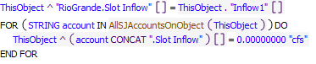

**Referenced Functions**

* RPL Object Icon AllSJAccountsOnObject

1.2 RPL Object Icon ReconcileConfluenceInflow2ToCompactDelivery

**Statements**

Statements

1.3 RPL Object Icon ReconcileConfluenceInflow2UsingCurtailment

**Statements**

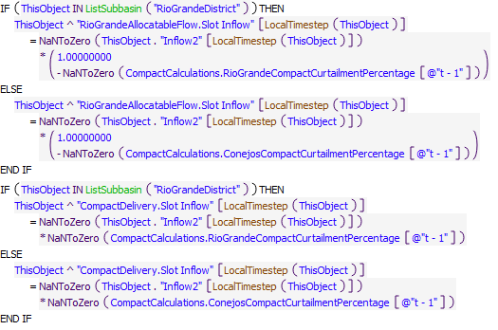

**Referenced Functions**

* RPL Object Icon LocalTimestep
* RPL Object Icon ListSubbasin

2 RPL Object Icon Reach Account Gain Loss

2.1 RPL Object Icon CochitiToElephantButteSJCLoss

**Statements**

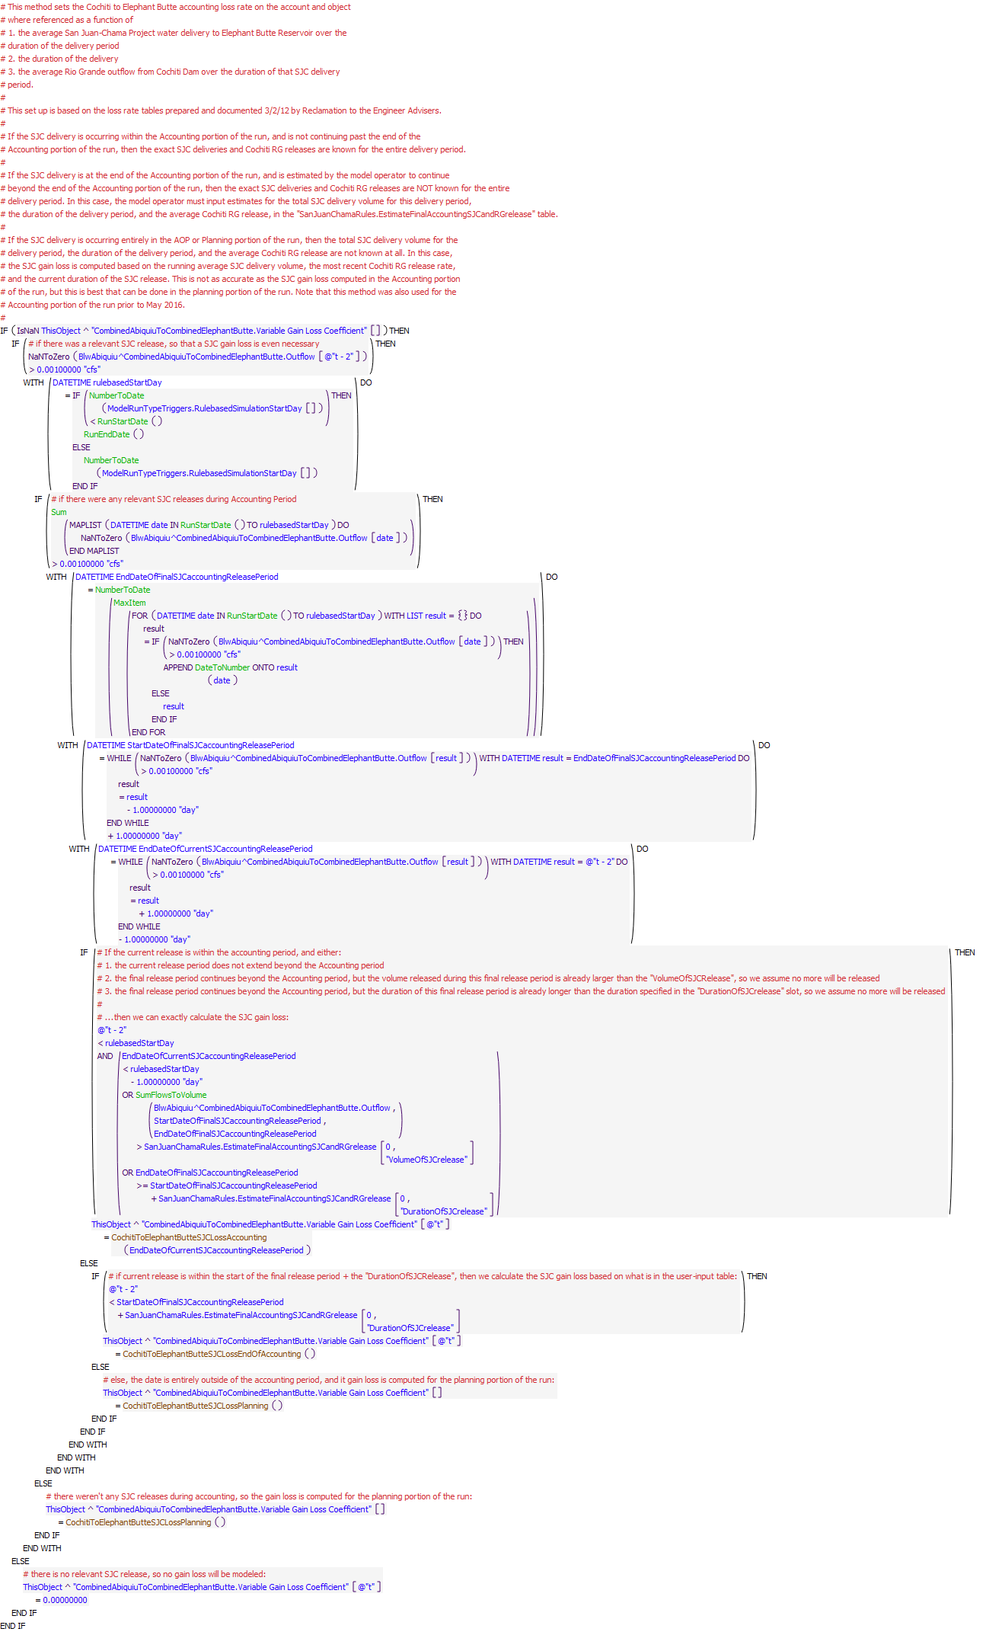

**Referenced Functions**

* RPL Object Icon CochitiToElephantButteSJCLossEndOfAccounting
* RPL Object Icon CochitiToElephantButteSJCLossAccounting
* RPL Object Icon CochitiToElephantButteSJCLossPlanning
* RPL Object Icon Sum
* RPL Object Icon MaxItem
* RPL Object Icon SumFlowsToVolume
* RPL Object Icon DateToNumber
* RPL Object Icon RunEndDate
* RPL Object Icon NumberToDate
* RPL Object Icon RunStartDate

2.2 RPL Object Icon ElephantButteToCaballoRioGrandeGainLoss

**Statements**

Statements

3 RPL Object Icon Reach Account Slot Inflow

3.1 RPL Object Icon ReconcileLocalInflowToCompactDelivery

**Statements**

Statements

3.2 RPL Object Icon ReconcileLocalInflowUsingCurtailment

**Statements**

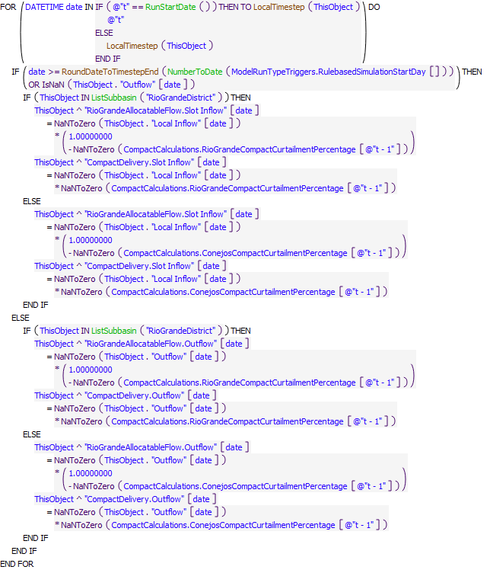

**Referenced Functions**

* RPL Object Icon LocalTimestep
* RPL Object Icon RoundDateToTimestepEnd
* RPL Object Icon ListSubbasin
* RPL Object Icon NumberToDate
* RPL Object Icon RunStartDate

3.3 RPL Object Icon AllConejos

**Statements**

Statements

4 RPL Object Icon Reservoir Account Gain Loss

4.1 RPL Object Icon Porportional Gain Loss

**Statements**

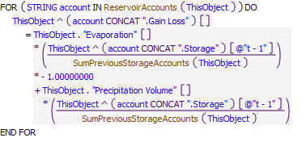

**Referenced Functions**

* RPL Object Icon ReservoirAccounts
* RPL Object Icon SumPreviousStorageAccounts

4.2 RPL Object Icon CaballoRioGrandeGainLoss

**Statements**

Statements

5 RPL Object Icon Reservoir Account Reconciliation

5.1 RPL Object Icon HeronReconcileRioGrandeOutflow

**Statements**

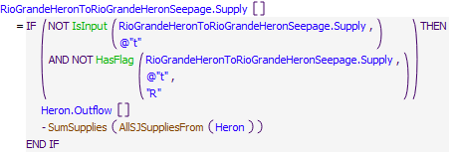

**Referenced Functions**

* RPL Object Icon AllSJSuppliesFrom
* RPL Object Icon SumSupplies
* RPL Object Icon IsInput
* RPL Object Icon HasFlag

5.2 RPL Object Icon ElVadoReconcileRioGrandeOutflow

**Statements**

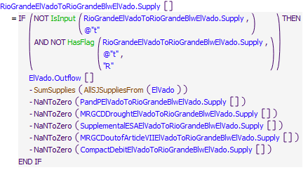

**Referenced Functions**

* RPL Object Icon AllSJSuppliesFrom
* RPL Object Icon SumSupplies
* RPL Object Icon IsInput
* RPL Object Icon HasFlag

5.3 RPL Object Icon AbiquiuReconcileRioGrandeOutflow

**Statements**

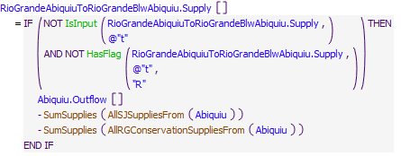

**Referenced Functions**

* RPL Object Icon AllSJSuppliesFrom
* RPL Object Icon AllRGConservationSuppliesFrom
* RPL Object Icon SumSupplies
* RPL Object Icon IsInput
* RPL Object Icon HasFlag

5.4 RPL Object Icon CochitiReconcileRioGrandeOutflow

**Statements**

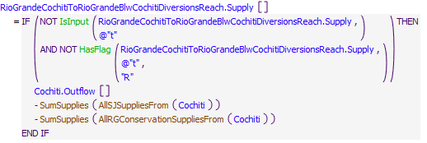

**Referenced Functions**

* RPL Object Icon AllSJSuppliesFrom
* RPL Object Icon AllRGConservationSuppliesFrom
* RPL Object Icon SumSupplies
* RPL Object Icon IsInput
* RPL Object Icon HasFlag

5.5 RPL Object Icon JemezReconcileRioGrandeOutflow

**Statements**

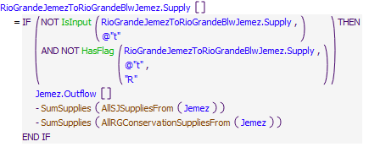

**Referenced Functions**

* RPL Object Icon AllSJSuppliesFrom
* RPL Object Icon AllRGConservationSuppliesFrom
* RPL Object Icon SumSupplies
* RPL Object Icon IsInput
* RPL Object Icon HasFlag

5.6 RPL Object Icon ElephantButteReconcileRioGrandeOutflow

**Statements**

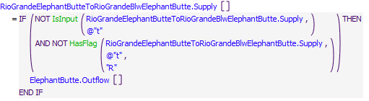

**Referenced Functions**

* RPL Object Icon IsInput
* RPL Object Icon HasFlag

5.7 RPL Object Icon CaballoReconcileRioGrandeOutflow

**Statements**

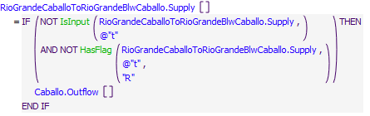

**Referenced Functions**

* RPL Object Icon IsInput
* RPL Object Icon HasFlag

5.8 RPL Object Icon NambeReconcileSJOutflowAndOtherStuff

**Statements**

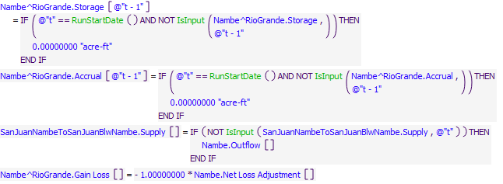

**Referenced Functions**

* RPL Object Icon RunStartDate
* RPL Object Icon IsInput